7(3) NUMBER into ALGEBRA
Title | Matching Expressions
Hours | 1
Aims | To understand the meaning of algebraic expressions. To be able to match algebraic expressions to their meaning in words.
Pedagogy | - Fluency
Activity  (details) | Starter  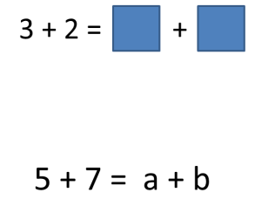  Think / Pair / Share  What goes in the boxes?  What is ‘a’ and what is ‘b’?  Ask pupils to share their answers, the discussion should lead pupils to an understanding that ‘a’ and ‘b’ could be any values that sum to 5. If pupils do not suggest negative numbers or decimal numbers then lead them to consider this.  Main Activity  Give the class some word statements and ask them to write an expression on their white boards. Increase the level of difficulty, e.g  “ Show me a number add 2”  “Show me a number multiplied by 3”  “Show me a number divided by 5”  “Show me a number add two then multiplied by 7.”  This activity provides an opportunity to explain that the multiplication sign is not used when writing algebraic expressions and to introduce brackets.  Pupils to then complete the matching activity. This is differentiated from simple expressions to expressions involving brackets and indices.  Ask pupils to choose one of their expressions and write down 5 equivalent expressions.  Plenary  Class discussion, expressions equivalent to 3y + 4
>H | Pupils to write equivalent expressions containing brackets and indices.
H | Pupils to match expressions to their meaning in words including expressions containing brackets and indices.
M | Pupils to match expressions to their meaning in words, including expressions containing brackets.
L | Pupils to match simple expressions to their meaning in words.
<L | Pupils to collect like terms.

